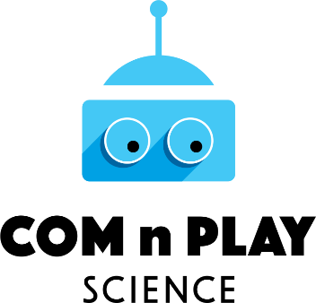

The COMnPLAY SCIENCE Project:
Learning science the fun and creative way!
Teaching coding is currently gaining momentum across the world to help young people develop technological fluency and deeper understanding of how the digital world is created, how it might be used to meet our needs, how we might repair or modify it. At the same time, the maker movement of independent innovators, designers and tinkerers has dynamically entered the landscape of innovative education, non-formal and informal learning, offering an unprecedented opportunity for educators to advance a progressive educational agenda. Across the spectrum of these emerging creative learning activities, the elements of fun and playfulness are dominant harnessing children’s sense of joy, wonder and natural curiosity, achieving high levels of engagement and learner’s personal investment in learning. The links and contributions of these creative learning approaches and activities to science education are strong and obvious, albeit still only little explored and understood in depth.
The COMnPLAY SCIENCE project aims to help Europe better understand the new ways in which non-formal and informal science learning is taking place through various coding, making, and play activities that young Europeans (children, adolescents and young adults) are nowadays increasingly engaged with, outside school and higher education science classrooms, beyond the formal boundaries of science education.
Carefully positioning the research within the context of the overarching contemporary discourses on Science, Technology, Engineering, (Arts) and Mathematics (STEM/STEAM) education, Responsible Research and Innovation (RRI), and science capital, the project’s main objectives are to:
- Develop an appropriate conceptual and methodological framework integrating all aspects of the project into a unifying conceptual map.
- Setup a European-wide community of stakeholders, including learners, educators, facilitators and policy makers from diverse fields, to contribute, guide and help assessing the conducted research.
- Identify, pool and analyse diverse existing coding, making and play-based practices taking place outside formal science classrooms which bear some promise for non-formal and informal science learning.
- Conduct in-depth learner-centred participatory empirical research on selected practices.
- Gain a deep understanding of the impact that this kind of non-formal and informal science learning has on formal science education, traditional informal science learning interventions, young people as learners and citizens, as well as, on society.
- Communicate and disseminate the messages and outcomes of the project widely, and enable the exploitation of the findings of the research through the development of relevant guidance for practitioners and recommendations for policy development and further research.
The main results stemming from the project include:
- An online inventory of all the identified and pooled practices, appropriately categorized and annotated in the light of the findings of the research, available to stakeholders and the public.
- A set of community building methods and tools for everyone wishing to get involved in community building linked to the project.
- A Web-based game promoting and supporting the continuous prolonged engagement of learners and their facilitators in the field research.
- The COMnPLAY-Science Knowledge Kit, a modular set of reader-friendly, practice-oriented publications, encapsulating the findings of the project.
- The COMnPLAY-Science Roadmap for Europe, a detailed concerted account by the consortium, the stakeholder communities and policy makers of the potential for short-, medium- and long term impact of coding, making and play-based non-formal and informal science learning.
- Numerous public events (workshops, training seminars, conferences, contests, fairs), often combined with training activities (winter and summer schools).
The project started 1st of June 2018, has a 3-year duration and has received 3,1M€ funding from the European Union’s Horizon 2020 research and innovation programme. The consortium consists of 11 distinguished members from 10 European countries (Austria, Finland, Germany, Greece, Malta, Netherlands, Norway, Spain, Sweden, UK) bringing together the multifaceted necessary expertise required for the project, complementing each another, representing the stakeholders in the world of innovative non-formal and informal science learning, and reflecting the geographical, cultural and socioeconomic diversity of Europe.
Consortium Members
Norwegian University of Science and Technology, Norway (coordinator) | University of Oulu, Finland | Foundation for Research and Technology – Hellas, Greece
 |  | 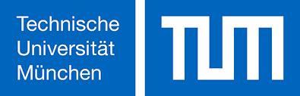
Eindhoven University of Technology, Netherlands | Uppsala University, Sweden | Technical University of Munich, Germany
 | 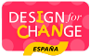
University of Malta, Malta | Design for Change initiative, Spain | ovos media GmbH, Austria
 | 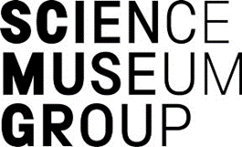
King's College London, UK | Science Museum Group, UK

Web & Social media
Web Site: http://comnplayscience.eu  YouTube: https://bit.ly/2Hq5FsK | Facebook: https://fb.me/ComNPlayScience  Twitter: @comnplayscience
ResearchGate: https://www.researchgate.net/project/CoM-n-Play-Science

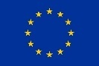
This project has received funding from the European Union’s Horizon 2020 research and innovation programme under grant agreement No 787476. This document reflects only the authors’ view. The Research Executive Agency (REA) and the European Commission are not responsible for any use that may be made of the information it contains.

